U11-U14 finishing
Category: Technical: Shooting
Difficulty: Beginner
Technique (20 mins)
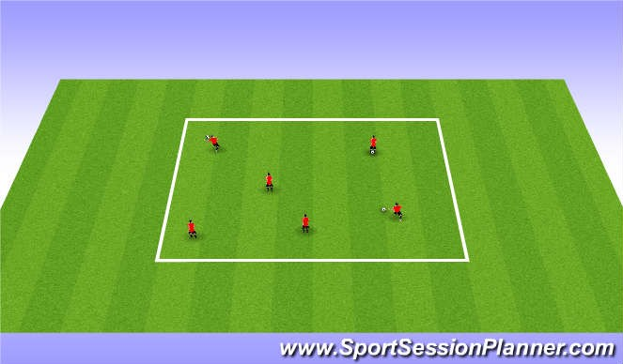
1.Have players start with ball in hands
2.Use proper Technique to strike the ball (toe down ankle locked) 3. Move to punting the ball in air
Learning Objectives

Technical
Toe Down Ankle locked
Psychological
Make players feel comfortable with the appropriate technique
Social
Can work in pairs or individually

Technical shooting from ground (20 mins)
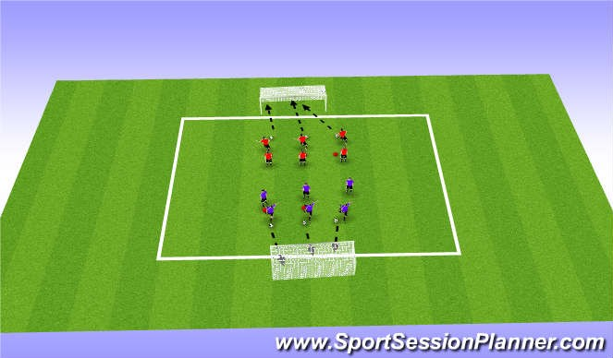
- Player starts behind cone
- Player takes touch to Right or Left side of cone (depending on which foot coach wants to work on)
- Player strikes ball on to net with power using proper technique
(toe down, ankle locked, swing from hip)
- Coaches can add different moves into the session with it.
- Players must go on coaches command
Learning Objectives

Technical
Toe Down Ankle locked
Psychological
Make players feel comfortable with the appropriate technique
Social
Can work in pairs or individually

Going to goal full speed (25 mins)
- Red player dribbles in leaves ball for blue player at pole  - Blue receives ball at the pole  - Blue player races to goal while red player runs around cone to defend player  - If blue player finishes the ball before red catches him/her are awarded the point  - if attacking player hits ball on cone and scores on GK its wort2pts | 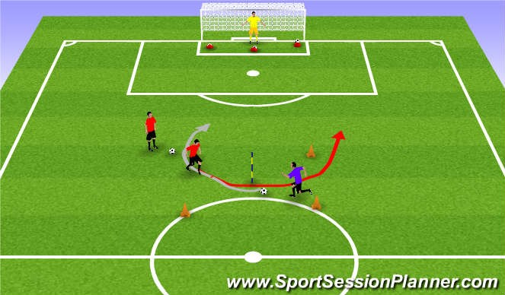  Learning Objectives  Technical  Toe Down Ankle locked  Psychological  Make players feel comfortable with the appropriate technique  Social  Can work in pairs or individually

